內容

Iperf Server 2

Iperf server 2

Client side (RouterX) 3

Information of Edge Router 3

Change IP 3

Change Duplex 4

Iperf (Dual Test) 5

Iperf (Single Test): 6

# Iperf Server

## Iperf server

1. Login to the iperf server
2. In the home directory of guna , there is 3 files. You can use ls –ltr to check.

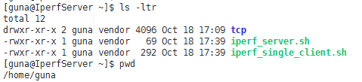

As server side type“ ./iperf_server.sh”



You can see the questing ask for input port number and then you can type the port number to trigger iperf server.

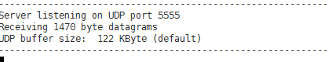

As the result, you can see the iperf server is listening on UDP port 5555

# Client side (RouterX)

## Information of Edge Router

Username : ubnt Password: ubnt

|  |  |  |
| --- | --- | --- |
| Interface | IP | Usage |
| Eth0 | 192.168.1.1/24 | Management LAN |
| Eth3 | static | Use for testing Lease Line |
| Eth4(PPPoE) | 202.134.118.47/32 | Use for testing PPPoE |

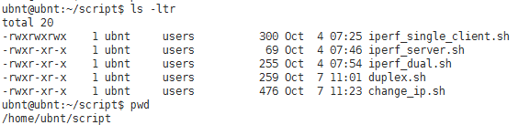

## Change IP

Before:

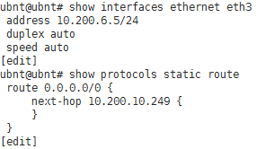

Use change ip sciprt

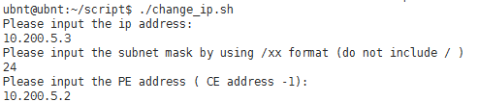

After (if the 41.10 route is already exist, the script will delete the current route and add back a new route to the configuration):

## Change Duplex

Before:



Use duplex.sh

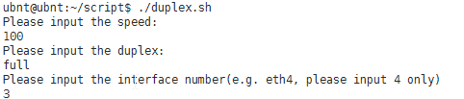

Result:

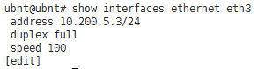

## Iperf (Dual Test)

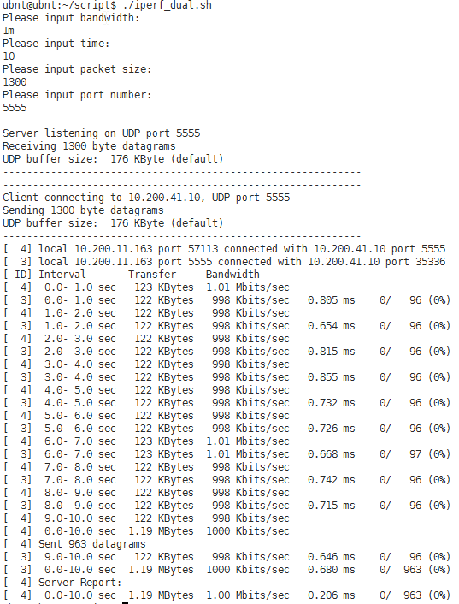

## Iperf (Single Test):

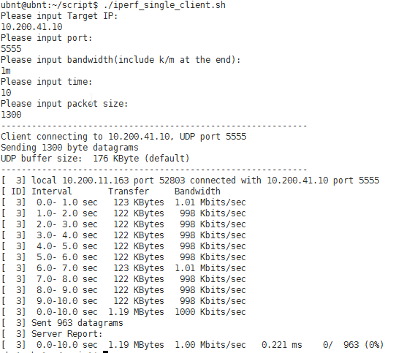

Remark:

Please define the same port in server side and client side.